**Defying, Death and Other Things**

The first time Gabe Amaro almost died, he remembers nearly drowning. He couldn’t have been more than six years old.

At the start of the interview, I asked Gabe to tell me something interesting about himself. I had told him that I would be asking about his immigration experience and expected him to tell me something about his childhood in Brazil. Instead, our conversation began with a bold assertion: Gabe is unkillable.



Gabe is currently a sophomore at American University. He was born in Brazil and grew up speaking Portuguese. Gabe moved to the United States when he was eleven years old and jumped to the sixth grade, a level above where he had been in Brazil. He spoke no English and felt woefully out of place.

“Do you know how hard it is to take the standardized tests in Massachusetts when you never learned what pi is?” he quips. “Or how to find the radius of a circle?”

Within two months of living in the United States, he was speaking English conversationally. When I listen for it, I can still hear the hint of an accent that reveals the Portuguese under the English. The accent, among other things it seems, is something he’s learned to hide under layers of bravado.

Gabe got bullied at school every day for three years. At first it was because he couldn’t speak English, and later it was just because he was foreign. He couldn’t eat, he couldn’t sleep, and in a house full of men who’d rather bottle their emotions than speak of them (two older brothers and a father) there was no outlet. He’d come home and tell his mom that he had a good day instead of a terrible one, even though inside the pressure was crushing him.

He laughs immediately after telling me this. “And now I’m unkillable!”

I ask Gabe how many times would he estimate he’s almost died, if he’s so unkillable. He muses, deciding on ten and counting out loud. “There was the time I almost drowned, the time with the bookcase, the time I fell off a cliff...”

I was there for the cliff, I remind him. That night we had been walking through the woods in the pouring rain, trying to reach the Chain Bridge and cross from D.C. into Virginia. There was an overgrown path I found that would take us to the highway so we could cross over.

The words, “Be careful, it looks steep,” had hardly left my mouth when I saw him push past me, take a step forward, and immediately plummet straight down. There was a moment where he didn’t move and I thought he’d snapped his neck, but then he got back up and continued as though nothing had happened.

Gabe is excited about that memory for a reason other than cheating death. “That’s the first night we talked about philosophy,” he says, and immediately follows it up with, “You know, for someone to understand themselves, they must first hate themselves.”

He explains this theory which he loosely based on Jung’s theory of the shadow. The shadow, he tells me, is essentially the worst version of yourself. It is the bad and the unconscious parts of your personality that you don’t want to acknowledge. To Gabe, it is essential to accept the shadow so that you can control it. You must introspect and see yourself as someone with a shadow to stay away from it. Life inevitably throws you suffering, and without knowing your own shadow you would have no idea how to cope and would succumb to the darkest parts of yourself.

Throughout the interview, Gabe has taken a nonchalant attitude towards life, almost an irreverence. He treats being unkillable like a fun fact instead of something vaguely concerning. He talks about being bullied relentlessly for three years and a second later he pivots with a joke. I ask what he did about his shadow and here, he hesitates.

Gabe tells me suffered from sleep paralysis, and for two months every time he went to sleep, he would wake up paralyzed and unable to shake the feeling that a physical manifestation of a shadow demon, massive and terrifying, was watching him from the corner of the room.

“It’s stupid,” he says, looking away from the camera. “I couldn’t conceptualize what was happening in my life so I thought there was an actual entity following me.”

One night, Gabe got sick of being unable to sleep. He went to bed and woke up paralyzed as usual, only this time he challenged the demon. Sleep paralysis makes it so that you can’t move, but internally Gabe was screaming, and he chased the shadow away.

Things in the outside world got better as time went on too, Gabe says. He watched a lot of stand up comedy, started journaling, read philosophy, sought reckless death-defying adventures on the regular, and became “the charismatic person you know now.”

I ask him what he’d do if something was able to hurt him and for a second time he pauses.

“I’m gonna explain my life with a few lines,” he says, leaning out of frame to grab a notebook. He scrawls something on the paper then holds it up to the camera for me to see.

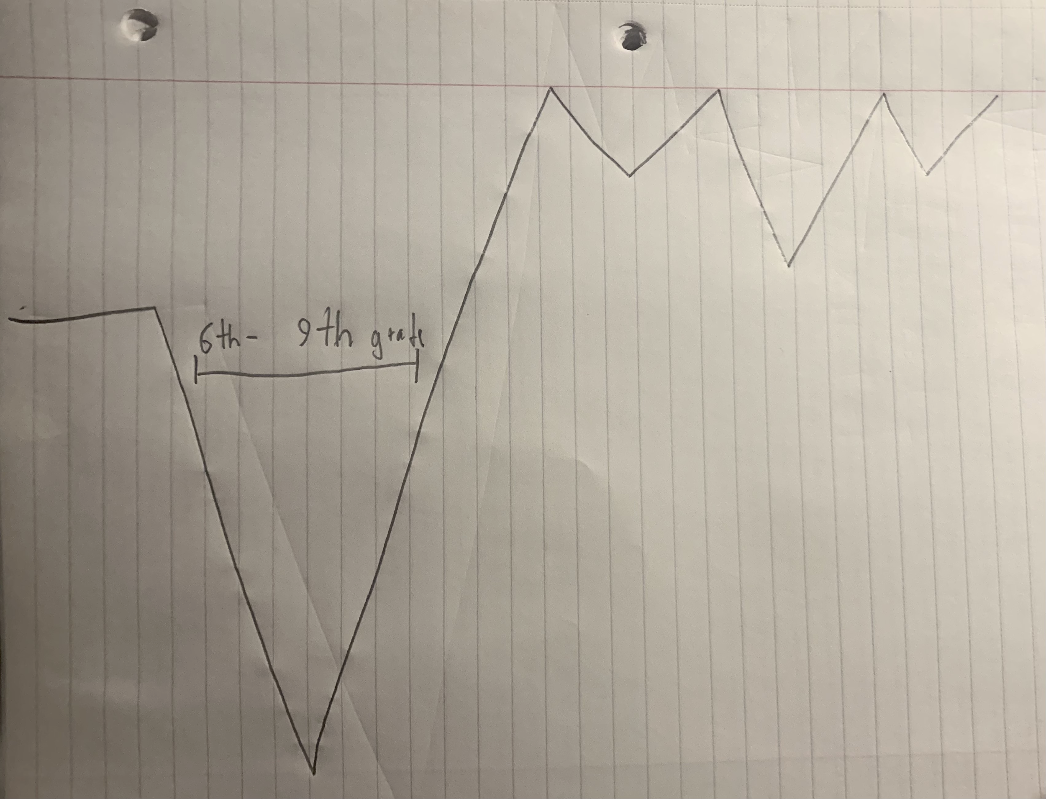

“This is me prior to moving.” He points to a flat line at the start of the scribbled timeline.

“This is me in the middle school years.” The graph takes a sharp dip downwards, bottoming out at the lowest point, then takes an incline upwards.

“And this is how I am now,” he says, finally pointing to the end of the graph. It’s up higher than the rest of how he maps his life and has a series of small dips one after another.

“After you’ve been through something horrendous for so long then nothing can compare to it.”